



NAME:THARSHINI M

CLASS:CSE F

ROLL:230701361

EXPERIMENT-4

1. Create a prototype with familiar and unfamiliar navigation elements. Evaluate ease of use with different user groups using proto.io

AIM: The aim is to develop a prototype incorporating both familiar and novel navigation elements and assess usability among diverse user groups using Proto.io.

Familar and UnFamiliar Design  Home

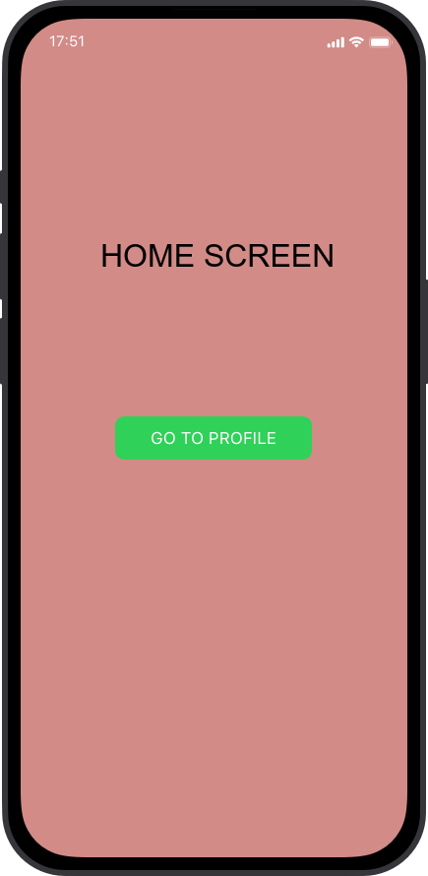

Familar and UnFamiliar Design  Profile

